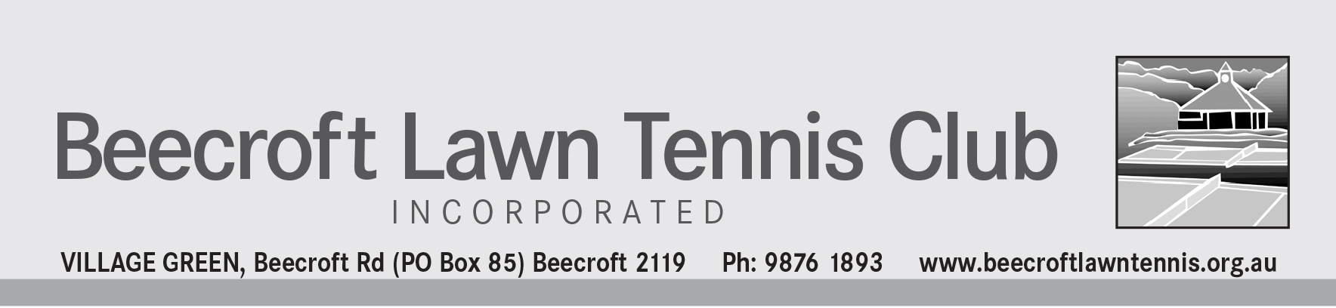

ABN 53 261 478 247

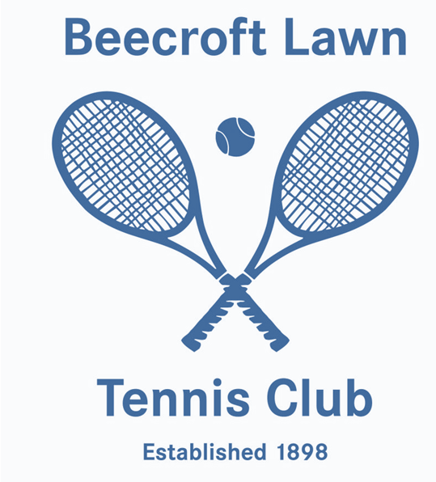

M E M B E R S H I P A P P L I C A T I O N

Welcome. The Beecroft Lawn Tennis Club was established in 1898. Over 100 years of sporting tradition.

Beecroft has 5 tennis courts - 3 natural lawn courts and two synthetic grass courts. The clubhouse is simple and well furnished and families with young children are able to use the facilities as we are not
licensed.

The natural lawn courts are open to members from February to November each year. Annual renovation of the grass courts is undertaken December through January.
The synthetic courts are open for members and hirers from 7am to 10.30pm every day of the year.
At Beecroft we expect standard tennis clothing and footwear to be worn and this includes the most recently designed tennis styles and colours.

Tennis Activities
The annual fee enables members to play on one of 4 Club days per week.
• Monday Seniors Mixed
• Tuesday Ladies
• Thursday Ladies
• Saturday Mens, Ladies, Mixed

For a small additional fee, members may also play on two or more of these days. Convenors are elected by the members each year and arrange sets on Club days.

Whilst most members only play on one of these Club days, both lawn and synthetic courts can be used at other times provided hirers are not using the synthetic courts and/or the lawn courts are not required by the groundsman for mowing, marking, watering etc.

Visitors are always welcome and should be introduced to the convenor on arrival. A fee of $10 per visitor is payable. Restrictions exist on the number of times any one visitor can play except under special circumstances decided by the Club's
Committee.

Social members are able to play up to 6 times per year.

Associates are short term members for up to 3 months.

Monday Seniors Enjoy social tennis and any person aged 55 or over can participate. Courts are available from 7am to 1 pm.
Midweek Ladies Tuesday and/or Thursday
Enjoy social tennis and courts are available from 7am to 1pm. Team(s) may also play in the Thursday Ladies Badge competition

Saturday Mens, Ladies & Mixed – All Ages
Enjoy social tennis and courts are available from 12 noon to 6pm. Teams also play in the Saturday afternoon Badge competition.

Badge
This is a competition for Mens and Ladies teams from clubs throughout the Sydney metropolitan area. Autumn Badge runs from March to July and Spring Badge from August to November. Our club selectors are elected each year by the members to select teams. Beecroft teams play on our natural grass courts while other clubs have either lawn or synthetic grass courts. Each player selected pays a Badge fee.

Club Championships
Beecroft holds its club championships annually and all members are encouraged to participate. Events include Open Mens and Ladies singles, Mens and Ladies doubles, Mixed doubles, Special Mens singles and doubles and Senior Mens, Ladies and Mixed doubles. Club championships are restricted to Full Members only.

Inter-Club Challenge
For over 40 years, Beecroft and Cheltenham clubs have played each other for the Schubert Shield. Mens, Ladies, Mixed and/or Senior teams participate on a date agreed between the two Clubs.

Fundays
Members and visitors can enjoy these days during the year where players of all standards participate in a round robin American mixed doubles format for example.

Fees
Beecroft membership fees are very reasonable compared to other tennis centres and clubs and your annual registration fee to Tennis NSW is paid by the club.
For new members the annual fee is pro-rata’d from the month your application is accepted to the end of the calendar year. In addition, a joining fee is payable.
For new members who are full time students under 25 years old at a school, college or university, a considerably reduced annual fee is payable. Half this annual fee is payable if you join between July and December. Joining fee is minimal.

BEECROFT LAWN TENNIS CLUB INCORPORATED
(incorporated under the Associations Incorporations Act 2009)
APPLICATION FOR MEMBERSHIP

Mr/Mrs/Ms
(Full name of Applicant)

of
(Address)

Post Code Occupation Date of Birth: _____/_____/_________
(if under 25 years)

Home Phone: Mobile:

Email Address:

Hereby apply to become a full / social / associate (please circle appropriate membership) member of the above mentioned incorporated association. In the event of my admission as a member, I agree to be bound by the constitution of the association for the time being in force.

Please tick the day/s of club play you wish to play. Note there is an additional fee for multiple days of play.
Saturday Tuesday Ladies
Monday Seniors over 55’s Thursday Ladies

  Please tick if you hold a pensioner concession card, No.

Please tick if you are already registered with Tennis NSW. Reg. No.

Please tick if you were introduced to the Club by an existing member. Their name:

Please tick if you are a full time student. Evidence must be attached.

Signature of applicant Date _________________________
(or parent if under 18 years)

How did you hear about BLTC?

Tennis Grade history (past 2 years)
Proposer

I ______________________________, a member of the club nominate the applicant, who is personally known to me, for membership of the club.

As the proposer how do you rate the above player?

Signature _______________________________ Date ________________________
Seconder

I ________________________________, a member of the club nominate the applicant, who is personally known to me, for membership of the club.

As the seconder how do you rate the above player? _________________________________________________

Signature _______________________________ Date _________________________

